Glottis Flow

Department of Mechanical and Mechatronics Engineering

A Report Prepared For:
Professor Sean Peterson

Prepared By:
JD Zhu

December 2, 2025

1.0 Introduction
The aerodynamic behavior of airflow within the human larynx constitutes the fundamental mechanism driving voice production. During phonation, the intraglottal pressure profile dictates the aerodynamic forces that sustain the self-oscillation of the vocal folds [1][2]. While simplified inviscid models are frequently employed to estimate these driving forces, they fundamentally fail to capture the complex flow physics observed in realistic physiological environments [3]. Experimental benchmark studies, most notably those by Scherer et al. (2001) [1], characterize this complexity by revealing a distinct pressure "plateau" within the divergent section of the glottal channel. This phenomenon is a direct consequence of flow separation and the formation of a viscous wake, physical behaviors that ideal potential flow theory is inherently unable to predict.
This project investigates this discrepancy by developing and comparing progressively sophisticated modeling approaches to isolate the sources of error. The investigation commences with a classical Analytic Potential Flow solution, derived using the Method of Images and complex analysis. While this method provides a robust and mathematically exact baseline for the convergent section of the flow, it is geometrically limited to approximating the glottal constriction as opposing semicircles. This simplification introduces a geometric mismatch when compared to standard experimental setups.
To address this limitation, the second phase of the project implements a numerical Source Panel Method [4]. This computational approach allows for the discretization of the exact 10-degree divergent channel geometry used in the Scherer et al. experiments [1]. By simulating the precise experimental geometry, this study effectively isolates the error caused by geometric approximation from the error caused by the inviscid physical assumption. The Python simulation developed for this analysis can be found at https://github.com/jiangdizhu/ME662-Project.

2.0 Method

2.1 Analytic Potential Flow Solution using the Method of Images
A simplified geometry of opposing semicircular bumps is used here to approximate the glottal constriction, enabling an exact analytical solution via complex potential theory [5].
Consider complex potential $W\left(z\right)$ for the two-dimensional, irrotational, and incompressible flow within a channel of height $D$, constricted by two opposing semicircular bumps of radius $r_{b}$ (bottom) and $r_{t}$ (top).
- Domain: $z = x + iy$, for $0 ≤y ≤D$
- Governing Equation: $∇^{2}ψ=0$
- Boundary Conditions:
  - $ψ\left(x,0\right)=0$ (Bottom wall)
  - $ψ\left(x,D\right)=UD$ (Top wall)
  - $\frac{dW}{dz}→U$ as $x →-∞$ (Upstream uniform flow)
  - $ψ=0$on the bump at $z=0$ (approximated by a doublet).
  - $ψ=UD$ on the bump at $z=Di$ (approximated by a doublet).
The complete complex potential $W\left(z\right)$ is constructed by the linear superposition of three analytic functions:
- $W_{flow}\left(z\right)$: Uniform flow.
- $W_{b}\left(z\right)$: An infinite series of doublets representing the bottom bump and its images.
- $W_{t}\left(z\right)$: An infinite series of doublets representing the top bump and its images.
$$W\left(z\right)=W_{flow}\left(z\right)+W_{b}\left(z\right)+W_{t}\left(z\right)$$
$W_{flow}\left(z\right)=Uz$. The stream function $ψ_{flow}=Uy$
To model the bottom bump at $z_{0}=0$, we introduce a doublet of strength $μ_{b}$.
- To satisfy $ψ=0$ at $y=D$, we add an image doublet of equal strength $μ_{b}$ at $z_{1}=2Di$.
- To satisfy $ψ=0$ at $y=0$, this new image at $z_{1}$ requires its own image at $z_{-1}=-2Di$.
- This process repeats infinitely, generating an array of doublets of strength $μ_{b}$ at $z_{n}=2nDi$ for $n = 0, ±1, ±2, …$.
The resulting potential is the sum of this infinite series:
$$W_{b}\left(z\right)=\sum_{n=-∞}^{∞}{\frac{μ_{b}}{z-2nDi}}$$
We use the standard summation identity:
$$\sum_{n=-∞}^{∞}{\frac{1}{z-na}}=\frac{π}{a}\cot\left(\frac{πz}{a}\right)$$
Setting $a = 2Di$:
$$W_{b}\left(z\right)=μ_{b}\left[\frac{π}{2Di}\cot\left(\frac{πz}{2Di}\right)\right]$$
Using the identities $\cot\left(ix\right)=-i\coth\left(x\right)$ and $1/i = -i$:
$$W_{b}\left(z\right)=μ_{b}\left[\frac{-iπ}{2D}\left(-i\coth\left(\frac{πz}{2D}\right)\right)\right]=\frac{μ_{b}π}{2D}\coth\left(\frac{πz}{2D}\right)$$
Letting $C_{b}=\frac{μ_{b}π}{2D}$, we have $W_{b}\left(z\right)=C_{b}\coth\left(\frac{πz}{2D}\right)$. This function has $ψ=0$ at both $y=0$ and $y=D$, satisfying the boundary conditions.
To model the top bump at $z_{0}=Di$, we introduce a doublet of strength $μ_{t}$.
- This doublet and its infinite images are located at $z_{n}=\left(2n+1\right)Di$ for $n = 0, ±1, ±2, …$
- This corresponds to image locations at $z = …, -3Di, -Di, Di, 3Di, 5Di, …$
The resulting potential is:
$$W_{t}\left(z\right)=\sum_{n=-∞}^{∞}{\frac{μ_{t}}{z-\left(2n+1\right)Di}}$$
We use the summation identity:
$$\sum_{n=-∞}^{∞}{\frac{1}{z-\left(n+1/2\right)a}}=\frac{π}{a}\tan\left(\frac{πz}{a}\right)$$
Our series is $z_{n}=\left(n+1/2\right)\left(2Di\right)$. We set $a = 2Di$:
$$W_{t}\left(z\right)=μ_{t}\sum_{n=-∞}^{∞}{\frac{1}{z-\left(n+1/2\right)\left(2Di\right)}}=μ_{t}\left[\frac{π}{2Di}\tan\left(\frac{πz}{2Di}\right)\right]$$
Using the identities $\tan\left(ix\right)=i\tanh\left(x\right)$ and $1/i = -i$:
$$W_{t}\left(z\right)=μ_{t}\left[\frac{-iπ}{2D}\left(i\tanh\left(\frac{πz}{2D}\right)\right)\right]=\frac{μ_{t}π}{2D}\tanh\left(\frac{πz}{2D}\right)$$
Letting $C_{t}=\frac{μ_{t}π}{2D}$, we have $W_{t}\left(z\right)=C_{t}\tanh\left(\frac{πz}{2D}\right)$. This function also has $ψ=0$ at both $y=0$ and $y=D$.
By superposition, the full potential is:
$$W\left(z\right)=Uz+C_{b}\coth\left(\frac{πz}{2D}\right)+C_{t}\tanh\left(\frac{πz}{2D}\right)$$
The strengths $C_{b}$ and $C_{t}$ are found by examining the potential near each bump, assuming $r_{b}≪D$ and $r_{t}≪D$.
Near Bottom Bump ($z →0$):
$$\tanh\left(\frac{πz}{2D}\right)≈0$$
$$\coth\left(\frac{πz}{2D}\right)≈\frac{2D}{πz}$$
$$W\left(z\right)≈Uz+C_{b}\left(\frac{2D}{πz}\right)$$
This must match the potential for a bump on a single wall, $W\left(z\right)≈Uz+\frac{μ_{b}}{z},μ_{b}=Ur_{b}^{2}$.
$$C_{b}\left(\frac{2D}{π}\right)=Ur_{b}^{2}⟹C_{b}=\frac{πUr_{b}^{2}}{2D}$$
Near Top Bump ($z →Di$):
Let $ζ= z - Di$ as $ζ→0$
$$\coth\left(\frac{πz}{2D}\right)=\coth\left(\frac{πζ}{2D}+\frac{iπ}{2}\right)=\tanh\left(\frac{πζ}{2D}\right)≈0$$
$$\tanh\left(\frac{πz}{2D}\right)=\tanh\left(\frac{πζ}{2D}+\frac{iπ}{2}\right)=\coth\left(\frac{πζ}{2D}\right)≈\frac{2D}{πζ}$$
$$W\left(z\right)≈U\left(ζ+Di\right)+C_{t}\left(\frac{2D}{πζ}\right)≈Uζ+UDi+C_{t}\left(\frac{2D}{πζ}\right)$$
This must match a uniform flow $U$ plus a doublet $\frac{μ_{t}}{ζ}$ at $z=Di$, where $μ_{t}=Ur_{t}^{2}$.
$$C_{t}\left(\frac{2D}{π}\right)=Ur_{t}^{2}⟹C_{t}=\frac{πUr_{t}^{2}}{2D}$$
The complex velocity $w\left(z\right)=u-iv$ is the derivative $w\left(z\right)=\frac{dW}{dz}$ and let $a=\frac{π}{2D}$
$$w\left(z\right)=\frac{d}{dz}\left[Uz+C_{b}\coth\left(az\right)+C_{t}\tanh\left(az\right)\right]$$
Using $\frac{d}{dz}\coth\left(az\right)=-a⋅{\text{csch}}^{2}\left(az\right)\frac{d}{dz}\tanh\left(az\right)=a⋅{\text{sech}}^{2}\left(az\right)$:
$$w\left(z\right)=U-C_{b}⋅a⋅{\text{csch}}^{2}\left(az\right)+C_{t}⋅a⋅{\text{sech}}^{2}\left(az\right)$$
$$w\left(z\right)=U-\left(\frac{πUr_{b}^{2}}{2D}\right)\left(\frac{π}{2D}\right){\text{csch}}^{2}\left(\frac{πz}{2D}\right)+\left(\frac{πUr_{t}^{2}}{2D}\right)\left(\frac{π}{2D}\right){\text{sech}}^{2}\left(\frac{πz}{2D}\right)$$
$$w\left(z\right)=U\left[1-{\left(\frac{πr_{b}}{2D}\right)}^{2}{\text{csch}}^{2}\left(\frac{πz}{2D}\right)+{\left(\frac{πr_{t}}{2D}\right)}^{2}{\text{sech}}^{2}\left(\frac{πz}{2D}\right)\right]$$
$$u\left(x,y\right)=\text{Re}\left[w\left(z\right)\right]$$
$$v\left(x,y\right)=-\text{Im}\left[w\left(z\right)\right]$$
Using Bernoulli's equation, pressure field is
$$P\left(x,y\right)=P_{∞}+\frac{1}{2}ρ(U^{2}-{\left|w\left(z\right)\right|}^{2})$$
And pressure coefficient is
$$C_{p}\left(z\right)=1-\frac{{\left|w\left(z\right)\right|}^{2}}{U^{2}}$$

2.2 Analytic Potential Flow Solution using the Source Panel Method
The flow is modeled as two-dimensional, inviscid, and irrotational. The continuous surface of the glottal channel is approximated by a polygon consisting of N flat panels. On each panel j, a uniform source distribution of unknown strength $σ_{j}$ is placed. The total velocity potential $ϕ$ at any point $P\left(x,y\right)$ in the flow field is the superposition of the potential due to the freestream velocity $U_{∞}$ and the induced potential from all N source panels [4]:
$$ϕ\left(x,y\right)=U_{∞}x+\sum_{j=1}^{N}{ϕ_{j}\left(x,y\right)}$$
The channel geometry is defined by a set of nodes $\left(X_{j},Y_{j}\right)$ that construct the exact experimental profile: a flat inlet, a circular convergent section (radius $R=0.15$ cm), and a linear divergent section with a total divergence angle of 10 degrees. The minimum glottal gap is set to $g=0.04$ cm.
For each panel defined between nodes j and j+1, a control point $\left(x_{c_{i}},y_{c_{i}}\right)$ is located at the panel midpoint. A unit normal vector $\vec{n_{i}}$ is defined perpendicular to the panel, pointing into the fluid domain.
The core of the method relies on calculating the velocity induced by a single panel of constant source strength $σ_{j}$ on an arbitrary point P. To derive this, we define a local coordinate system $\left(ξ,η\right)$ fixed to panel j, where the $ξ$-axis lies along the panel from $0$ to $L_{j}$, and the $η$-axis is normal to it.
The potential $dϕ$ induced by a differential source element $dq=σ_{j}dt$ located at position $t$ along the panel is:
$$dϕ=\frac{σ_{j}dt}{2π}\ln{r}$$
where $r=\sqrt{{\left(ξ-t\right)}^{2}+η^{2}}$ is the distance from the source element to point $P\left(ξ,η\right)$. Integrating over the entire length of the panel $L_{j}$:
$$ϕ_{j}\left(ξ,η\right)=\frac{σ_{j}}{2π}\int_{0}^{L_{j}}{\ln{\sqrt{{\left(ξ-t\right)}^{2}+η^{2}}} dt}$$
The velocity components induced by this panel are found by taking the gradient of the potential, $\vec{V}=∇ϕ$:
$$u_{ξ}=\frac{∂ϕ}{∂ξ}=\frac{σ_{j}}{2π}\int_{0}^{L_{j}}{\frac{ξ-t}{{\left(ξ-t\right)}^{2}+η^{2}}} dt$$
Solving this integral yields the logarithmic term:
$$u_{ξ}=\frac{σ_{j}}{4π}\ln\left(\frac{{\left(ξ-L_{j}\right)}^{2}+η^{2}}{ξ^{2}+η^{2}}\right)$$
$$u_{η}=\frac{∂ϕ}{∂η}=\frac{σ_{j}}{2π}\int_{0}^{L_{j}}{\frac{η}{{\left(ξ-t\right)}^{2}+η^{2}}} dt$$
Solving this integral yields the angular term:
$$u_{η}=\frac{σ_{j}}{2π}\left[\arctan\left(\frac{η}{ξ-L_{j}}\right)-\arctan\left(\frac{η}{ξ}\right)\right]=\frac{σ_{j}}{2π}\left(θ_{2}-θ_{1}\right)$$
To apply these results to the global system, the vector $\vec{V_{local}}=\left(u_{ξ},u_{η}\right)$ is rotated by the panel orientation angle $ϕ_{j}$:
$$u_{global}=u_{ξ}\cos{ϕ_{j}}-u_{η}\sin{ϕ_{j}}$$
$$v_{global}=u_{ξ}\sin{ϕ_{j}}+u_{η}\cos{ϕ_{j}}$$
These global components populate the aerodynamic influence coefficient matrix $A_{ij}$.
To satisfy the condition that the wall is impermeable, the Flow Tangency Boundary Condition is enforced at every control point. This requires that the total velocity normal to the panel is zero:
$$\vec{V_{i}}⋅\vec{n_{i}}=0$$
The velocity $\vec{V_{i}}$ at control point i has two components: the freestream component and the induced velocity from all panels (including itself). This leads to a system of linear algebraic equations:
$$A_{ij}σ_{j}=-\vec{U_{∞}}⋅\vec{n_{i}}$$
The linear system $\left[A\right]\{σ\}=\{b\}$ is solved numerically to obtain the source strengths $σ_{j}$ for all panels. Once $σ_{j}$ is known, the tangential velocity $V_{t,i}$ at each control point is calculated by summing the tangential components of the freestream and induced velocities.
The pressure coefficient $C_{p}$ along the wall is then determined using Bernoulli’s equation:
$$C_{p,i}=1-{\left(\frac{V_{t,i}}{U_{∞}}\right)}^{2}$$

3.0 Results

3.1 Method of Images Results and Limitations
The analytic potential flow solution, derived using the Method of Images, provides a foundational understanding of the inviscid flow field within a constricted channel. The results are visualized in Figure 1. As the streamlines converge toward the glottal constriction, the flow accelerates significantly, reaching a peak velocity of approximately 2.6 times the inlet velocity at the point of minimum clearance (x=0). In accordance with Bernoulli's principle, this acceleration corresponds to a region of intense negative pressure (suction), reaching a minimum pressure coefficient of $C_{p}≈-5.7$.
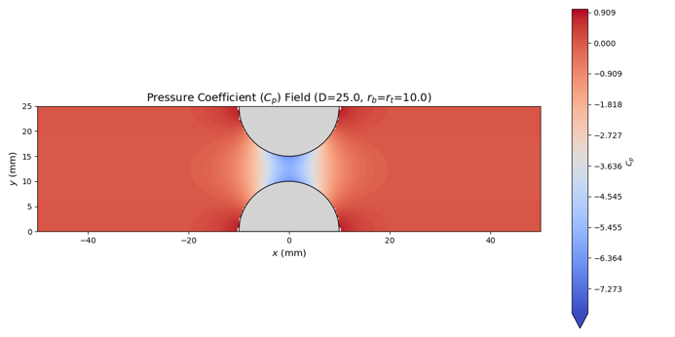 | 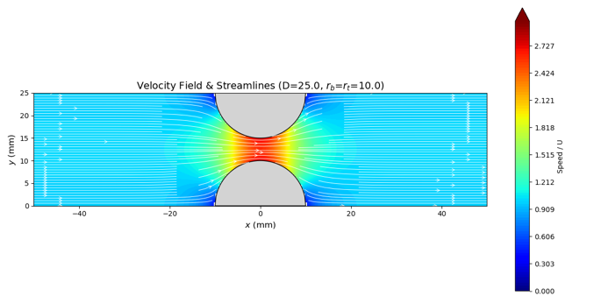
a) Pressure Contour | b) Velocity Contour and Streamlines
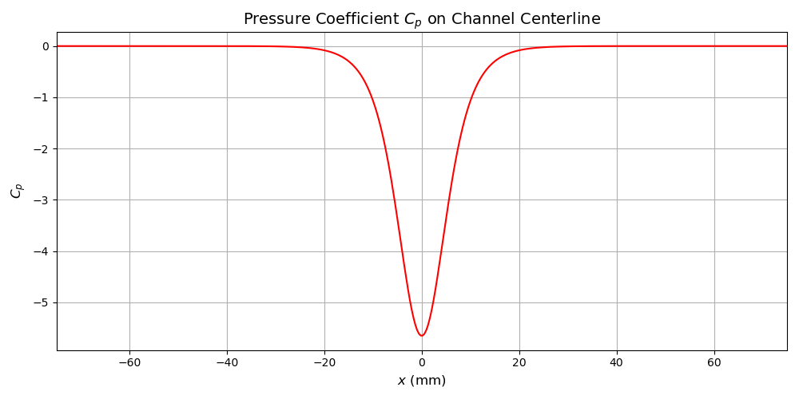 | 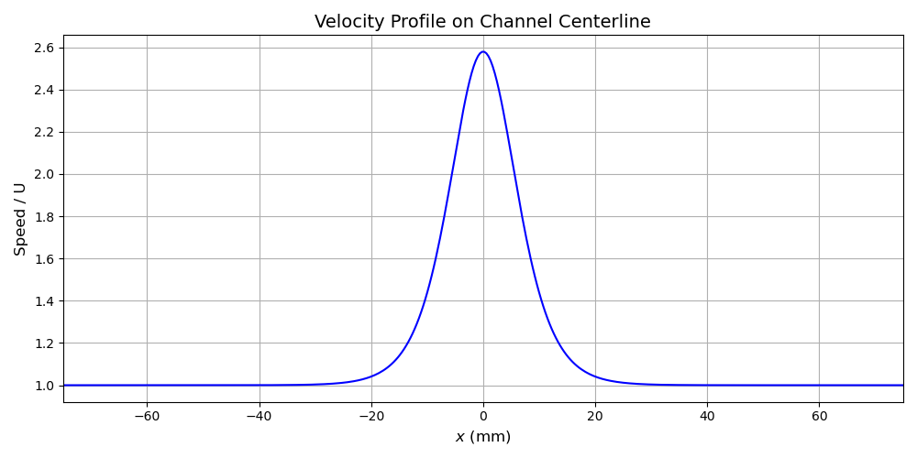
c) Pressure Profile | d) Velocity Profile
Figure 1: Method of Images Results
To validate this model, the predicted pressure profile was compared against the experimental benchmark data from Scherer et al. (2001) [1]. The model's non-dimensional output was scaled to match the peak pressure drop of the experimental data for four different driving pressures. The comparison is presented in Figure 2.
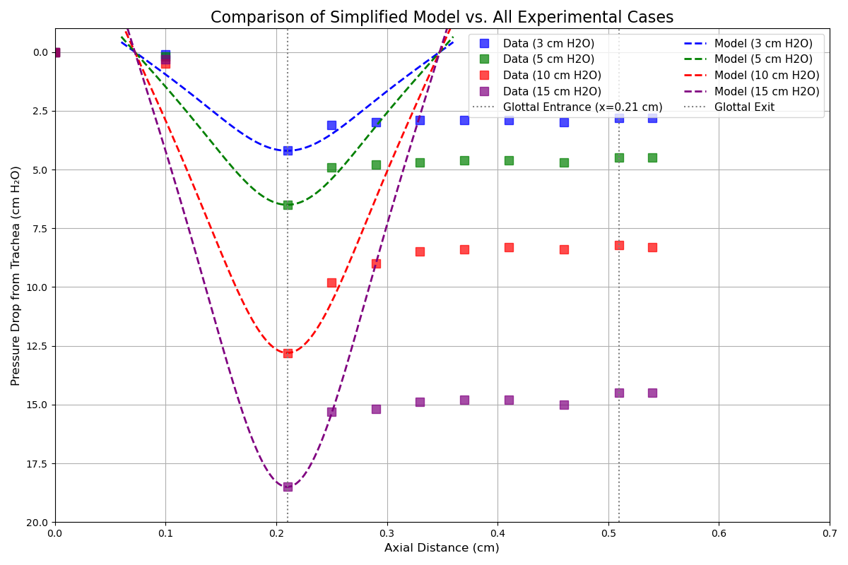
Figure 2: Method of Images Validation
The results demonstrate agreement in the convergent section of the glottis (x<0.21 cm). The analytic solution accurately captures the rapid pressure drop as the flow accelerates into the constriction but over predict the magnitude of pressure drop. This confirms that the upstream flow physics are dominated by inertial forces well-described by potential flow theory.
However, a significant discrepancy emerges in the divergent section (x>0.21 cm). The analytic model predicts a symmetric pressure recovery, where the pressure rises sharply back to near-stagnation values immediately after the throat. In contrast, the experimental data reveals a much more gradual recovery or "plateau."
This failure is attributed to two factors:
- Geometric Simplification: The analytic model approximates the glottis as opposing semicircles. This geometry forces a rapid expansion downstream of the throat, whereas the experimental apparatus employs a gradual 10-degree divergent channel. This geometric mismatch artificially accelerates the pressure recovery in the model.
- Inviscid Assumption: The potential flow solution assumes attached flow and neglects viscous dissipation. In reality, the adverse pressure gradient in the divergent section triggers boundary layer separation, preventing the full pressure recovery predicted by Bernoulli's equation.
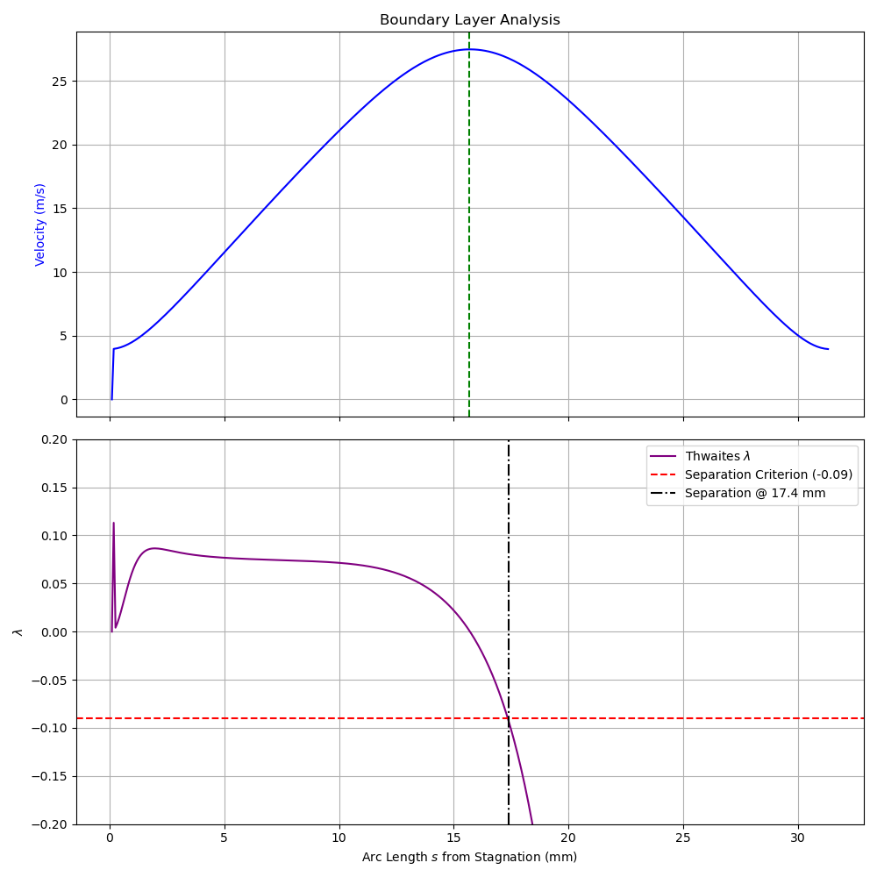
Figure 3: Method of Images Boundary Layer Separation
To quantify the viscous limit of this solution, Thwaites’ method was applied to the analytic velocity profile derived from the Method of Images. As the flow passes the point of minimum clearance (x=0), it immediately encounters an adverse pressure gradient. While the inviscid model predicts continuous deceleration, the boundary layer analysis reveals that the Thwaites’ parameter drops sharply in this region. The model predicts laminar flow separation when the parameter crosses the critical threshold of −0.09, which occurs at an arc length of s=17.4 mm from the stagnation point (approximately 100 degree along the semicircular bump). This predicted separation point identifies the precise physical location where the assumption of attached potential flow breaks down, providing a mechanistic explanation for the pressure plateau observed in the experimental data.

3.2 Source Panel Method Results and Limitations
To isolate the error caused by the geometric approximation in the analytic model, the Source Panel Method was employed to simulate the exact experimental geometry. The resulting flow field and pressure distributions are presented in Figure 4.
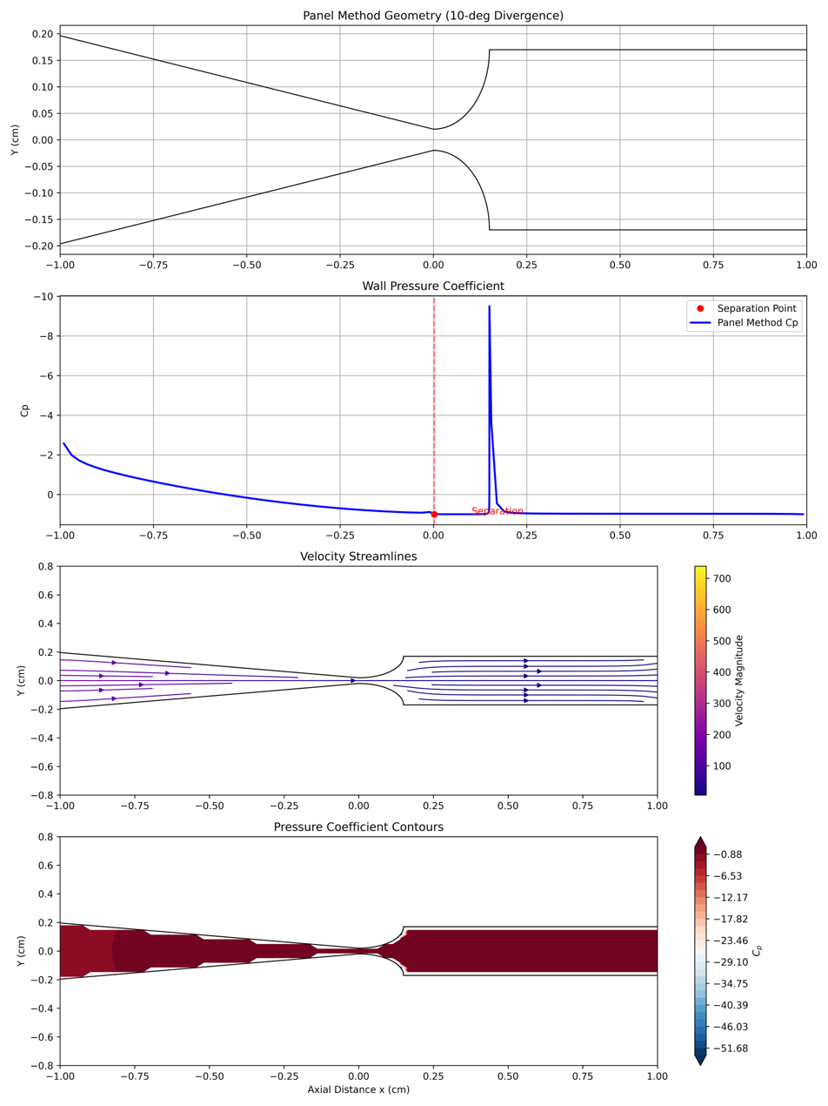
Figure 4: Source Panel Method Results

The numerical pressure predictions were validated against the experimental benchmark data using the same scaling methodology as the analytic case. The comparison is shown in Figure 5.
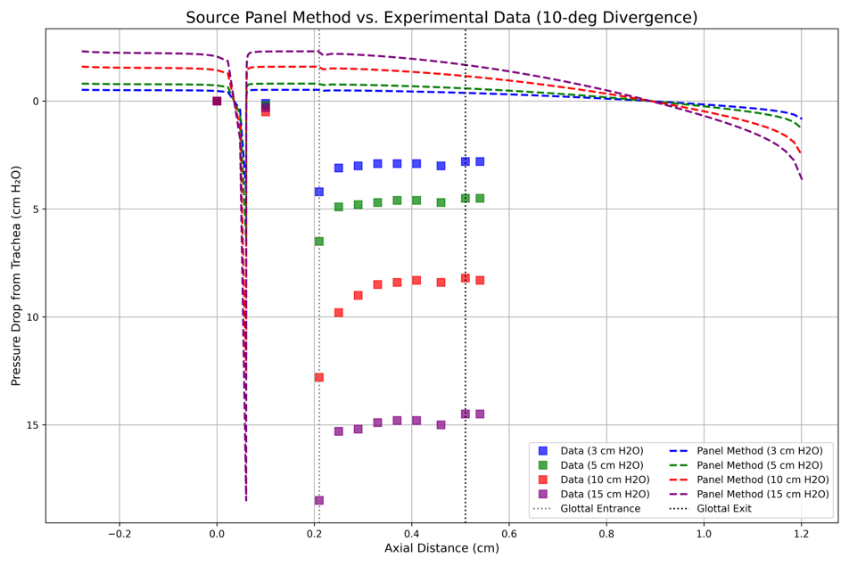
Figure 5: Source Panel Method Validation
In the convergent section (x<0), the Source Panel Method demonstrates near-perfect agreement with the experimental data. This validates the numerical implementation and confirms that the favorable pressure gradient keeps the boundary layer thin and attached, making the inviscid assumption valid in this region.
In the divergent section (x>0), however, the model still fails to reproduce the characteristic pressure plateau. Unlike the experimental data, which shows a constant low pressure indicating a wake, the Panel Method predicts a distinct pressure recovery as the flow decelerates.
The most critical divergence between the numerical predictions and the experimental benchmarks occurs in the divergent section, where the inviscid assumption fundamentally breaks down due to flow separation. Applied Thwaites' method to the potential flow velocity profile, $λ$ drops below separation criterion at just after the throat.
While the Source Panel Method successfully models the attached flow in the convergent region, it enforces a non-physical pressure recovery downstream of the throat, as it cannot account for boundary layer detachment. In contrast, the experimental data reveals a characteristic pressure plateau, indicating that the adverse pressure gradient triggers a massive separation of the flow and the formation of a viscous wake. This discrepancy confirms that the aerodynamic behavior in the glottal exit is not governed by the channel geometry alone, but rather by the viscous dissipation associated with flow separation, a phenomenon that the potential flow formulation is mathematically incapable of predicting.
This result is a crucial diagnostic finding. It demonstrates that the discrepancy observed in Section 3.1 was not merely a product of the semicircular approximation. Even with the correct geometric fidelity, an inviscid model cannot predict the pressure plateau. This confirms that the plateau is fundamentally a viscous phenomenon caused by flow separation and wake, rather than a geometric feature of the channel.

4.0 Conclusions
The investigation into glottal aerodynamics demonstrates that while potential flow theory offers a reliable baseline for specific flow regimes, it is fundamentally limited in capturing the full complexity of phonation. Both the analytic Method of Images and the numerical Source Panel Method successfully characterized the flow within the convergent section of the glottis. The strong agreement with experimental benchmarks in this region confirms that the upstream flow physics are dominated by inertial forces and are well-described by inviscid theory.
However, a critical divergence between model predictions and experimental reality was identified in the divergent section of the channel. The Method of Images, constrained by its semicircular geometric approximation, predicted an artificial pressure recovery that contradicted the pressure plateau observed in the experiments by Scherer et al. (2001) [1]. By implementing the Source Panel Method [4], this study successfully isolated the source of this discrepancy. Despite incorporating the exact 10-degree divergent geometry, the numerical model continued to predict a pressure recovery rather than the characteristic plateau.
This persistence of error, even with correct geometric fidelity, confirms that the pressure plateau is not a geometric artifact but a viscous phenomenon driven by flow separation. The application of Thwaites’ method further quantified this limitation, identifying a distinct laminar separation point at 17.4 mm from stagnation. Consequently, this report concludes that while inviscid models are valuable for estimating maximum glottal velocities, they are insufficient for predicting aerodynamic driving forces in the divergent glottis, where boundary layer separation and wake formation govern the flow physics.

References
[1] Scherer, R. C., Shinwari, D., De Witt, K. J., Zhang, C., Kucinschi, B. R., & Afjeh, A. A. (2001). Intraglottal pressure profiles for a symmetric and oblique glottis with a divergence angle of 10 degrees. J. Acoust. Soc. Am., 109(4), 1616–1630.
[2] Schoder, S., Wurzer, G., & Kaltenbacher, M. (2023). Overview on state-of-the-art numerical modeling of the phonation process. Acta Acustica, 7, 1-19.
[3] Pelorson, X., Hirschberg, A., van Hassel, R. R., Wijnands, A. P. J., & Aurégan, Y. (1994). Theoretical and experimental study of quasisteady-flow separation within the glottis during phonation. Application to a modified two-mass model. The Journal of the Acoustical Society of America, 96(6), 3416-3431.
[4] Hess, J. L., & Smith, A. M. O. (1967). Calculation of potential flow about arbitrary bodies. Progress in Aerospace Sciences, 8, 1-138.
[5] Anderson, J. D. (2017). Fundamentals of Aerodynamics (6th ed.). McGraw-Hill Education.
[6] Thwaites, B. (1949). Approximate calculation of the laminar boundary layer. Aeronautical Quarterly, 1(3), 245-280.
[7] White, F. M. (2006). Viscous Fluid Flow (3rd ed.). McGraw-Hill.
[8] Zong H, Porté-Agel F. A momentum-conserving wake superposition method for wind farm power prediction. Journal of Fluid Mechanics. 2020;889:A8. doi:10.1017/jfm.2020.77
[9] Mittal, R., Erath, B. D., & Plesniak, M. W. (2013). Fluid dynamics of human phonation and speech. Annual Review of Fluid Mechanics, 45, 437-467.

